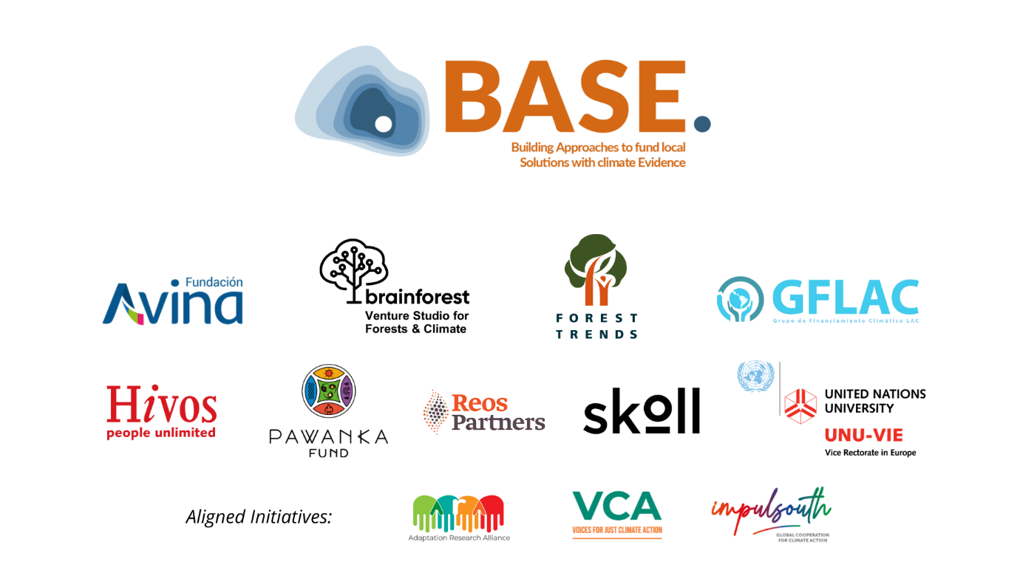

Application form for the first call of grants

February 2023

BEFORE SUBMITTING YOUR PROPOSAL, PLEASE CHECK THAT YOU COMPLY WITH THE FOLLOWING REQUIREMENTS

☐ | The application is submitted by a consortium (of 2 to 5 implementing organizations)
☐ | The consortium has designated a lead organization
☐ | The lead organization of the consortium has a legal identity with legal status able to sign on behalf of the organization
☐ | The lead organization of the consortium has a bank account that can receive funds from foreign accounts
☐ | The lead organization is based in the country in the Global South
☐ | All sections of the application are completed within the specified word limits.

BEFORE SUBMITTING YOUR PROPOSAL, PLEASE CHECK THAT YOU ATTACH THE FOLLOWING ELEMENTS

☐ | Application form (this document)
☐ | In case you chose option 2 of section 5.A.1, include the video explaining the climate rationale of your proposal
☐ | CV of the proposed researcher if you want to nominate one

- SUMMARY
Title of proposal | Please state the title of the proposal
Organizations presenting the proposal | Lead
Organizations presenting the proposal | Partners
Organization who invited to apply to BASE’s call | Name of the organization
Implementation area | Please state the country/ies where the project will be implemented
Brief description of the proposal
(Maximum 500 words)
Objectives | Include two main objectives you expect to achieve after the implementation of the proposed solution

- CONSORTIUM
Governance | Please describe how decisions will be taken between members of the consortium
Roles | Please describe roles of the members of the consortium
History | Please describe the relationship working together
  - Lead organization details
Name of organization |  | Registered legal entity name
Type of organization |  | Please indicate the nature of your organization. Remember that the lead organization must have legal identity with legal representative able to sign on behalf of the organization and have a bank account that can receive funds from foreign accounts.
Type of work |  | Please describe the type of work your organization/institution carries out, specifically in relation to the work it will be doing for the grant.
Registered address  (Organization that will sign the contract) |  | Street
 |  | Postal code
 |  | City
 |  | Country
Phone number |  | (Including country code)
Organisation website
Point person |  | Name
 |  | Cell phone
 |  | Email
  - Partner (please include details of all the partners that are part of the consortium. Copy and paste 3.B table if necessary)
Name of organization
Type of organization |  | Please indicate the nature of your organization.
Type of work |  | Please describe the type of work your organization/institution carries out, specifically in relation to the work it will be doing for the grant.
Organization website
Point person |  | Name
 |  | Cell phone
 |  | Email

- Context and problem identification
  - Location
Please indicate where you want to implement the proposal you are submitting, specifying municipalities, regions, and countries. It would be desirable to include maps.

  - Characteristics of the community (Maximum 300 words)
Please describe the community that live in the location described in section 4.A. Indicate its main characteristics, including information such as: socio demographics, ecosystems and natural resources, and main economic activities, among others.

  - What are the key issues faced by the community? (Maximum 300 words)
Please describe the most pressing issues faced by the community. These may include details of livelihood, ecosystem/environment, governance, gender, and/or overall development concerns (e.g., poverty, loss of biodiversity, conflict, gender discrimination, increase in deforestation, exploitation of natural resources, violence in the communities, among others). If there are particular members of the community who are especially affected by these concerns, please describe their experiences.

- Climate rationale and details of the proposed solution
  - Climate rationale
BASE understands that one of the main challenges that keep local communities from accessing climate finance is the development of a climate rationale in financing proposals e.g., how an idea will help increase climate resilience or greenhouse gas emissions reduction. We want to simplify the ways to develop a climate rationale.
For that reason, in this grant call you can select ONLY ONE of the three proposed alternatives to explain how your project connects to climate change.
    - Please indicate which option will you use to explain the climate rationale in Section 5.A.
☐ OPTION 1: I will submit a video to explain in my own words the problem our community faces in relation to climate change, and what our proposed solution is. (Please advance to section 5.A.1.1)
☐ OPTION 2: I will submit an essay to explain in my own words the problem our community faces in relation to climate change, and what our proposed solution is. (Please advance to section 5.A.1.2)
☐ OPTION 3: I will explain the problem our community faces in relation to climate change, and what our proposed solution is, by filling out this form. (Please advance to section 5.A.1.3)

      - OPTION 1: Please annex a short video with this proposal that explains in your own words the problem your community faces in relation to climate change, and what your proposed solution is. (Maximum 10 minutes)
Tell us about your community and your climate story. Please make sure that in the video you explain these elements:
- What life is like in your community and how climate change is affecting you? If you have experienced/been experiencing a climate-related disaster, please describe how this impacted your community (for example, longer drier season that led to crop losses).
- If there are any members of your community who are especially vulnerable to climate impacts, please elaborate on their experiences.
- Finally, please describe what solution you are proposing to minimize the impacts of climate change in your community and/or how the solution contributes to reducing greenhouse gas emissions, and why you think this fits your local needs best.
      - OPTION 2: Please annex a short essay with this proposal that explains in your own words the problem your community faces in relation to climate change, and what your proposed solution is. (Maximum 1,500 words)
Tell us about your community and your climate story. Please make sure that in the essay you explain these elements:
- What life is like in your community and how climate change is affecting you? If you have experienced/been experiencing a climate-related disaster, please describe how this impacted your community (for example, longer drier season that led to crop losses).
- If there are any members of your community who are especially vulnerable to climate impacts, please elaborate on their experiences.
- Finally, please describe what solution you are proposing to minimize the impacts of climate change in your community and/or how the solution contributes to reducing greenhouse gas emissions, and why you think this fits your local needs best.
      - OPTION 3: Please explain by filling out this form the problem your community faces in relation to climate change, and what your proposed solution is.
Please fill out items 5.A.1.3.1 to 5.A.1.3.4 below.
        - What climate-related hazard/s are affecting your community the most?
Please check the climate-related hazard/s affecting your community the most, based on your past or recent experiences. If you have observed changing trends (e.g. more frequent drought) or changing patterns (e.g. uncertainty in timing of rainfall) in any of these hazards, please describe as well.
 | Climate-related hazard (climate impact driver) | Observed changes  (For the selected hazard, indicate if you observed that it increased, decreased, or changed its variability)
☐ | Average temperatures
☐ | Extreme heat (heatwave)
☐ | Average rainfall
☐ | Heavy rainfall
☐ | Flooding
☐ | Aridity (long-term average dryness)
☐ | Drought
☐ | Wildfire
☐ | Severe windstorm
☐ | Tropical cyclone
☐ | Others: _____________________

        - Impact chain
Using an Impact Chain, please describe the effects of the most pressing climate-related hazard/s affecting your community. You may outline your experiences of single events (e.g., drought), changing trends (e.g. more frequent drought) or changing patterns (e.g. uncertainty in timing of rainfall), that were described in the previous section 5.A.1.3.1.

You can complete the impact chain using the template provided below and adjusted as needed or choose to upload a photo of your output instead.

How to draw an impact chain (adopted from CARE International’s CVCA Handbook):
- Step 1: Work on one climate-related event or change at a time. Indicate this on the left-most side of the chain. This event should be the most pressing one that you have selected in section 5.A.1.3.1
- Step 2: Identify 2 or 3 of the most direct impacts caused by the climate-related event or change.
- Step 3: Focusing on one direct impact at a time, identify 2 or 3 of the most important indirect impacts or consequences of the direct impact. Note that some indirect impacts can be linked to several direct impacts.

For reference, below are some examples of Impact Chains:
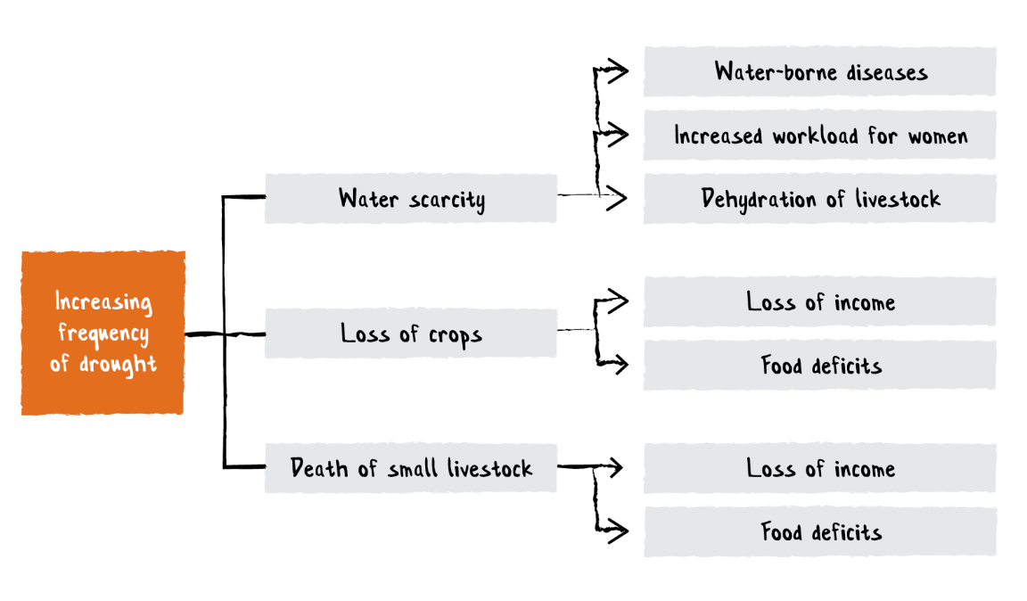
CARE International. For example, in a farming community, the increasing frequency of drought has led to the loss of crops, which in turn resulted in the loss of income among farmers as well as the deficit of food within the broader community.
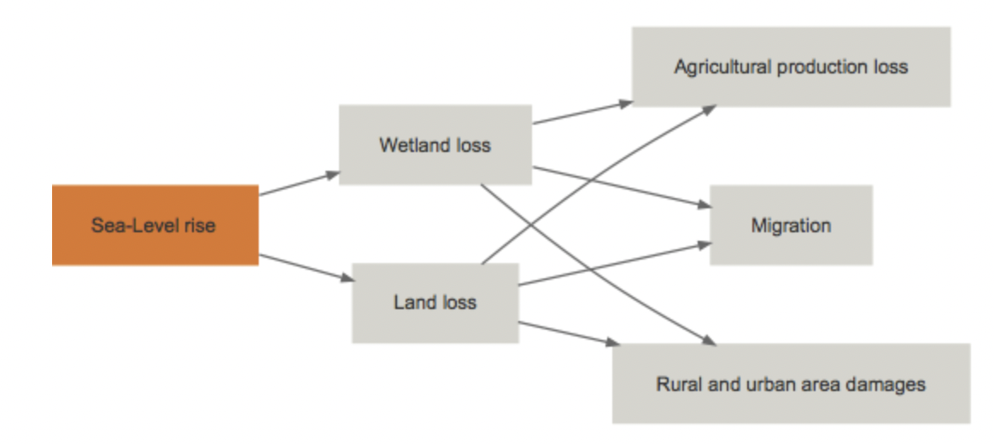
Potsdam Institute for Climate Impact Research. For example, in an island community, sea level rise has led to land loss, which in turn resulted in losses in agricultural production and damages in built areas, forcing some residents to migrate due to food insecurity and unsafe living conditions.

        - Which members of your community are most affected by these climate impacts?
Considering the impacts you have enumerated in the section above (5.A.1.3.2.), please identify which particular member/s of your community are most affected. Using the table below, provide a short explanation of why these members may be more sensitive or have less capacity to adapt to the identified impacts. One or more can apply.
Community members | Why are they more vulnerable to climate impacts?
Women
Children
Elderly
Persons with disabilities
Youth
LGBTQ+
Other (e.g., members with lower income or lower educational attainment): ________________________

For example, according to an IPCC report “the tasks of collecting firewood and water in some countries, which traditionally fall to women and girls, are heavily affected by adverse climate change impacts, which force the women and girls to travel further from their homes to complete the tasks and provide for their families. In turn, the longer journeys increase their exposure to gender-based violence outside the home.”

        - Proposed solution
To reduce the climate risk and enhance the resilience of your community, what solution would you like to propose under this grant? You may select from the options listed in the table below the one that most resemblance to your solution or indicate a different one that fits your needs better.

☐ avoiding deforestation
☐ increasing protected areas
☐ planting diverse native species
☐ managing biodiversity
☐ recognizing indigenous peoples and local communities’ tenure rights
☐ fire prevention and management practices
☐ strengthen capacities and create conditions for the empowerment of women, youth, and indigenous communities
☐ utilizing the resources of forests in a manner that conserves the environment and biodiversity, such as eco-tourism, ☐ sustainable forestry, and non-timber forest product harvesting
☐ establishing monitoring and early warning systems
☐ Other: ____________________________________________________________________________________

All proponents are required to fill out Section 5.B using the form
  - Details of the proposed solution
    - Activities (1,000 words)
- Provide details of the specific activities you will carry out to implement your proposed solution using this grant.
- Please describe how the proposal includes women and diversities in the implementation of the activities.

    - Potential effectiveness of proposed solution
- Please describe how your proposed solution improves the current situation of the community.

- Our goal is to promote flexibility and openness to new methods of measuring effectiveness, which is why we highly value a collaborative process for defining outcome indicators between implementing organizations, BASE, and the assigned researcher. However, we have also developed some general indicators, and we kindly request that you select the one or ones that you believe your project will contribute to.

☐ Number of hectares under restoration or conservation programs
☐ Number of reforested hectares
☐ Number of hectares that became protected areas.
☐ Number of people whose proportion of income derived from sustainable forest-based livelihoods has increased.
☐ Number of business opportunities created or strengthened based on a sustainable use of the forest
☐ Number of people with greater capacities to improve their living conditions.
☐ Number of women/youth/indigenous peoples empowered and/or in leadership positions to implement adaptation and mitigation measures related to forest management.
    - Involvement of the beneficiaries (Maximum 500 words)
- How have the final beneficiaries been involved in the elaboration of the proposal?
- Please describe how the proposal includes women and diversities perspective in the design of the activities.
- How will beneficiaries be involved in the implementation of the activities?

    - Relevant actors to be engaged (Maximum 250 words)
Please identify the actors to be engaged in the country, and whether a new relationship would be built. If the relationship is pre-existing, please identify the nature of the relationship(s), and for how long it has lasted.

    - Co-benefits (Maximum 250 words)
Please explain how the implementation of the activities contributes to generate positive transformations in the community at the environmental, social and economic levels.

    - Sustainability (Maximum 250 words)
- How is this project framed in other initiatives that are in course?
- Please explain future actions and/or needs identified to continue the solution once the implementation of the grant offered by BASE is completed
- Please comment how do you propose to maintain the solution under a scenario in which no other short-term funding is obtained.

- Budget
Considering the list of activities described in section 5.B.1, please complete the following table. Please think about the provided example as reference
Remember that the total amount must not exceed USD 40,000.
Activity | Description | Cost (USD) | Unit | Total
e.g. Plant trees in deforested areas | Purchase of seedlings and planting | 5 | 100 | 500
Total

Dimensions and examples of the gender-differentiated impacts of climate change, the role of women as agents of change and opportunities for women. Synthesis report by the secretariat

